

**Kenai Satellite Phone Rental**

**907-283-1603**

**www.kenaisatphone.com**

**To make a call:**

**DIAL: 00- COUNTRY CODE – AREA CODE – PHONE NUMBER (ex.00 1-907-283-1603)**

**FREE TEST NUMBER 001-480-752-5105**

**Press green key to initiate call. Press red key to end call.**

**Iridium satellites provide worldwide service however the service is intermittent. Every 10 minutes you have a chance of a new satellite.**

Iridium 9505a Instructions

**Warning: Antenna is very fragile.**

1. Stand outside (Sat Phone must have line of sight)
2. Press and hold power button for 5 seconds
3. Fully extend Antenna always pointing up.
4. Display will read “Searching for Network”.
5. Wait for the display to read “Registered”.
6. Note the signal strength in top left hand corner.

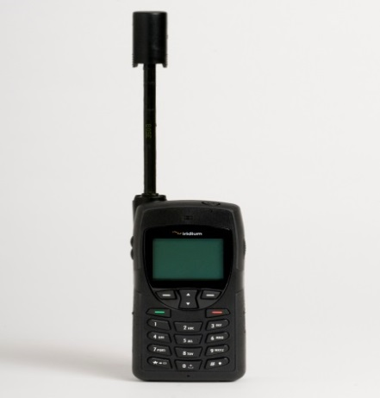

Important Numbers:

**Air Guard Rescue Coordination Center:**

**001-800-420-7230 or 1-907-551-7230.**

Alaska State Troopers: 001-907-262-4453

NOAA Weather Holtline: 001-800-472-0391

* Incoming text messages are free, Outgoing text messages are about $1.00 each.

*SMS Messaging with Iridium Satellite Phone KenaiSatPhone.com*

* To send a text TO an Iridium Phone go to <http://messaging.iridium.com/>

**Cell phone to Satellite Phone Text message**

The best way is to download the “SATWAY” App on Iphone or Android. This will allow you to send free text messages from your cell to a satellite phone. Some cell carriers won’t allow you to send texts to Sat Phones.

**Satellite Phone Text message to cell phone**

* Menu/ Messages / Create Message
* Type message, max 160 characters
* Options / Send / Add
* Enter cell phone number
* SEND, wait until SMS MESSAGE SENT OK is displayed. NOTE: you need a clear view of the sky.

**How to Read Your Messages**

# Incoming messages ARE NOT sent to your phone immediately. Turn on and leave phone for 5-10 minutes to receive messages.

-New SMS. Read Now? Will appear on screen.

 will also appear on top right of the display. (next to battery meter)

Scroll down to read the entire message press volume down button, or go to  Main Menu / Messages / Choose INBOX. DO NOT CHANGE ANY OF THESE SETTINGS.

**How to send a reply**

1. Options 5. You need a clear view of the sky
2. Reply 6. Options & Choose SEND
3. Press and hold the Clear button 7. Wait, and don’t press any buttons.
4. Compose your message

SMS MESSAGE SENT OK  Message Sent

SMS MESSAGE FAILED  message will not automatically resend. Try again.